Grid Systems
# Source: AI Source: Provided by: [Data Path: Persons Table -> ID Column: 1, Name_En Column: Motasem Essam] -> From: [ChatGPT] on [1/16/2026]
A Grid System is a type of distributed system in which computing resources from multiple locations (often geographically distributed) are combined to work together as a single system for large-scale computation or resource sharing.
Unlike cluster systems, which are tightly coupled and often in the same location, grid systems are loosely coupled and can use heterogeneous resources across organizations or regions.

Definition
# Source: AI Source: Provided by: [Data Path: Persons Table -> ID Column: 1, Name_En Column: Motasem Essam] -> From: [ChatGPT] on [1/16/2026]
A Grid System:
- Combines resources from multiple computers/networks
- Works on large computational problems or massive data processing
- Provides shared access to computing power, storage, and applications
- Nodes may belong to different organizations

Architecture Diagram
# Source: AI Source: Provided by: [Data Path: Persons Table -> ID Column: 1, Name_En Column: Motasem Essam] -> From: [ChatGPT] on [1/16/2026]
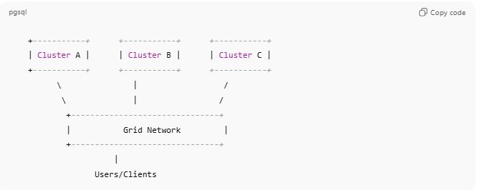
+-----------+ +-----------+ +-----------+
| Cluster A | | Cluster B | | Cluster C |
+-----------+ +-----------+ +-----------+
\ | /
\ | /
+-------------------------------+
| Grid Network |
+-------------------------------+
|
Users/Clients
- Each cluster/node contributes resources to the grid
- Users access the grid as a single, large system

How Grid Systems Work
# Source: AI Source: Provided by: [Data Path: Persons Table -> ID Column: 1, Name_En Column: Motasem Essam] -> From: [ChatGPT] on [1/16/2026]
- Users submit tasks or jobs to the grid middleware
- Middleware identifies available resources across the grid
- Jobs are distributed to multiple nodes (clusters or computers)
- Results are collected and combined

Key Characteristics
# Source: AI Source: Provided by: [Data Path: Persons Table -> ID Column: 1, Name_En Column: Motasem Essam] -> From: [ChatGPT] on [1/16/2026]
- Loosely coupled: Nodes can be geographically distributed
- Heterogeneous: Can use different hardware and operating systems
- Large-scale resource sharing: Combines CPU, storage, memory
- High scalability: Can handle thousands of nodes

Applications
# Source: AI Source: Provided by: [Data Path: Persons Table -> ID Column: 1, Name_En Column: Motasem Essam] -> From: [ChatGPT] on [1/16/2026]
- Scientific research (e.g., CERN, protein folding)
- SETI@home (analyzing radio signals for extraterrestrial intelligence)
- Weather forecasting and climate modeling
- Engineering simulations (fluid dynamics, aerodynamics)
- Large-scale rendering for movies or animations

Advantages
# Source: AI Source: Provided by: [Data Path: Persons Table -> ID Column: 1, Name_En Column: Motasem Essam] -> From: [ChatGPT] on [1/16/2026]
- Uses idle resources efficiently
- Enables computation too large for a single system
- Cost-effective: uses existing resources
- Supports collaboration between organizations

Disadvantages
# Source: AI Source: Provided by: [Data Path: Persons Table -> ID Column: 1, Name_En Column: Motasem Essam] -> From: [ChatGPT] on [1/16/2026]
- Complex setup and management
- Higher network latency than cluster systems
- Security and access control are more difficult
- Performance depends on network reliability

Grid Systems vs Cluster Systems
# Source: AI Source: Provided by: [Data Path: Persons Table -> ID Column: 1, Name_En Column: Motasem Essam] -> From: [ChatGPT] on [1/16/2026]
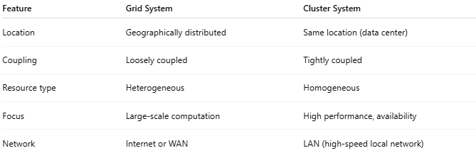
Feature | Grid System | Cluster System
Location | Geographically distributed | Same location (data center)
Coupling | Loosely coupled | Tightly coupled
Resource type | Heterogeneous | Homogeneous
Focus | Large-scale computation | High performance, availability
Network | Internet or WAN | LAN (high-speed local network)

Simple Analogy
# Source: AI Source: Provided by: [Data Path: Persons Table -> ID Column: 1, Name_En Column: Motasem Essam] -> From: [ChatGPT] on [1/16/2026]
- Grid System: Scientists around the world sharing their computers to solve a massive problem
- Cluster System: Scientists in the same lab working together on one powerful computer setup

